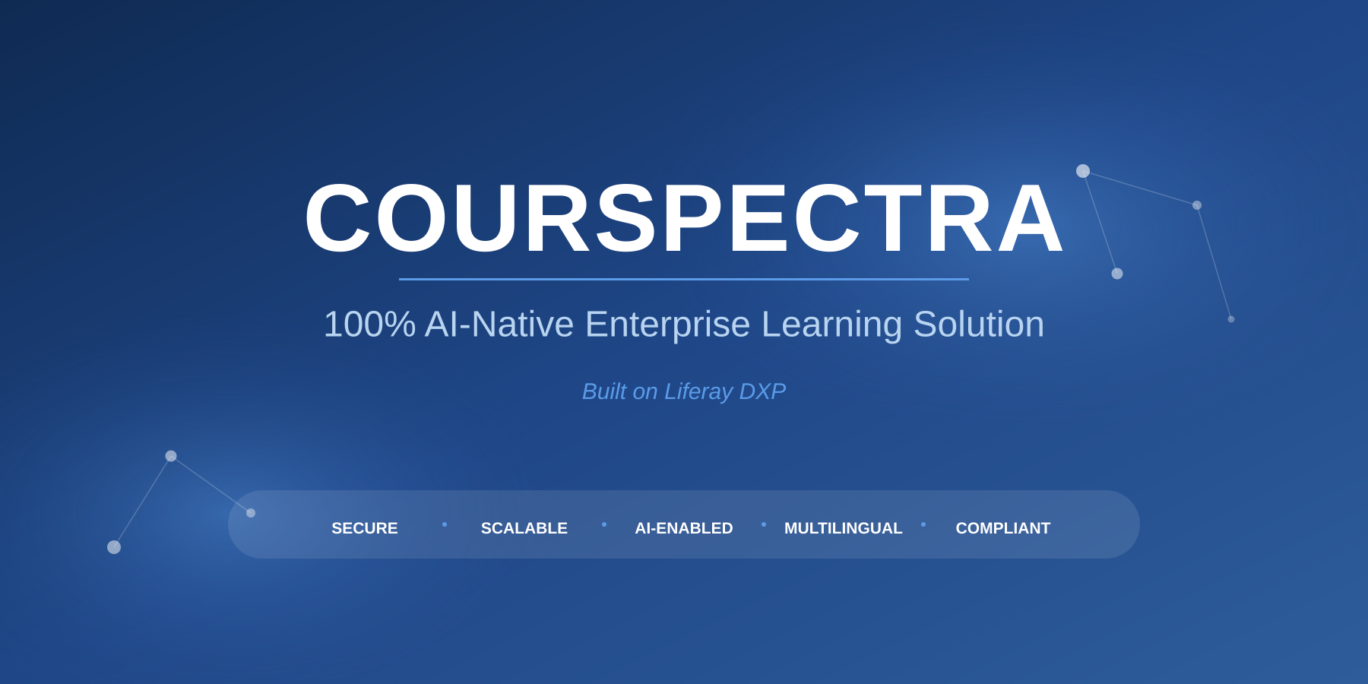
PRODUCT SHEET
Overview, Architecture & Capabilities
May 2026
courspectra.com

Table of Contents
1. Executive Summary 1
Key Differentiators 1
2. Who Courspectra Is For 1
2.1 Corporate Enterprises 1
2.2 Government Departments & Agencies 1
2.3 Public Sector Undertakings (PSUs) 1
2.4 Training Institutes & Educational Organizations 1
2.5 Regulatory Bodies & Certification Authorities 1
2.6 Large Workforce Organizations 1
3. Platform Foundation - Liferay DXP 1
3.1 Why Liferay DXP? 1
3.2 Courspectra OSGi Module Architecture 1
Module Categories 1
3.3 SCORM & Standards Compliance 1
4. Core Capabilities 1
4.1 Course & Training Management 1
4.2 AI-Native Learning Intelligence 1
4.3 Assessment & Examination 1
4.4 Analytics, Compliance & Reporting 1
4.5 Certification & Credentials 1
4.6 User, Role & Access Management 1
4.7 Communication, Engagement & Collaboration 1
5. User Roles & Role-Specific Features 1
5.1 Administrator 1
5.2 Training Coordinator 1
5.3 Instructor / Trainer 1
5.4 Content Manager 1
5.5 Learner 1
6. Security Architecture 1
6.1 Layer 1 - Perimeter Security 1
6.2 Layer 2 - Identity, Authentication & Authorization 1
6.3 Layer 3 - Application Security 1
6.4 Layer 4 - Data Security 1
6.5 Layer 5 - Monitoring, Audit & Governance 1
6.6 Government-Grade Deployment 1
7. Deployment Architecture 1
7.1 Cluster-Based Deployment Architecture 1
7.2 Tier Descriptions 1
Edge Tier 1
Web Tier 1
Application Tier 1
Data Tier 1
Supporting Services 1
7.3 Deployment Models 1
8. Integration & APIs 1
8.1 API Capabilities 1
8.2 Common Integrations 1
9. Customization & Extensibility 1
9.1 UI Customization 1
9.2 Functional Customization 1
9.3 Modular Architecture Benefits 1
10. Platform Specifications 1
11. Why Organizations Choose Courspectra 1
12. Implementation & Support 1
13. Get Started 1

1. Executive Summary
Courspectra is a 100% AI-native, enterprise-grade Learning Management System purpose-built for large organizations, government departments, public sector undertakings, and regulatory bodies. Trusted since 2016 and built on the proven Liferay DXP platform, Courspectra delivers a unified, secure, and intelligent learning ecosystem designed for measurable impact at enterprise scale.
Modern organizations face critical learning challenges - skill gaps impacting productivity, dispersed workforces across locations, compliance and policy rollouts at scale, multilingual workforce requirements, and stringent security and data sovereignty concerns. Courspectra addresses these challenges by delivering a unified, secure, AI-enabled learning ecosystem with the architectural strength of Liferay DXP underneath.

Key Differentiators
- AI-Native Architecture: Built ground-up with embedded AI agents that generate complete courses, lessons, topics, and question sets in minutes. AI also delivers personalized learning paths, predicts learner performance, and powers an admin AI desktop for natural-language platform interaction.
- Liferay DXP Foundation: Built on Liferay DXP - a Java EE platform with OSGi container that combines enterprise robustness with modular flexibility. Inherits Liferay's Content Management, Digital Asset Management, Collaboration, Personalization, Low-Code, and Headless API capabilities out of the box.
- 100% Blended Learning: Seamlessly unifies online self-paced learning with instructor-led classroom training, webinars, and offline access - all under a single tracking and assessment engine with attendance, performance, and certification flowing through one system.
- Enterprise & Government-Grade Security: Defense-in-depth security architecture spanning perimeter (WAF, DDoS protection), identity (MFA, SSO, RBAC), application (OWASP, proctoring), data (AES-256 encryption, HSM key management), and governance (audit logs, SIEM integration, compliance with ISO 27001, SOC 2, GDPR, DPDP Act 2023).
- Multilingual & Accessible: Native Unicode-compliant support for 20+ languages including major Indian regional languages, with Google Translator integration for automated content localization. Complies with WCAG 2.1 AA and configurable for GIGW guidelines.
- Unlimited Scalability: Horizontally scalable clustered architecture supporting unlimited concurrent users. Active-active node deployment with automatic node provisioning when load crosses thresholds, eliminating peak-time bottlenecks.
- Measurable Outcomes: Advanced analytics dashboards link training investments to performance results. Track completion rates, score distributions, pass rates by course and assessment type, learner-level credit accumulation, and predictive insights on at-risk learners.
- Flexible Deployment: Deploy on public cloud, government cloud (e.g., MeghRaj GCC), private cloud, on-premise infrastructure, hybrid combinations, or air-gapped environments. Containerized deployment via Docker and Kubernetes for cloud-native operations.

2. Who Courspectra Is For
Courspectra serves organizations with substantial workforces requiring structured, scalable, and secure learning management. The platform is optimized for the following segments:

2.1 Corporate Enterprises
- Large-scale Employee Training: Deliver structured employee training programs across geographies and business units with consistent quality and centralized governance.
- Compliance Learning: Manage mandatory compliance training (anti-bribery, POSH, information security, code of conduct) with auto-enrollment, deadline tracking, escalations, and audit-ready evidence.
- Skill Development Tracking: Track workforce skill development at scale with skill-tagged courses, competency mapping, and credit-based progression.

2.2 Government Departments & Agencies
- Digital Training Initiatives: Implement large-scale digital training initiatives with government-grade security, data sovereignty, and on-premise or government-cloud deployment.
- Policy Awareness Programs: Roll out new policies, regulations, and amendments to entire departments with mandatory completion tracking and acknowledgement.
- Capacity Building: Run multi-year capacity building programs across departments with structured curricula, multiple cohorts, and longitudinal performance analytics.

2.3 Public Sector Undertakings (PSUs)
- Centralized Employee Development: Streamline employee development across plants, regional offices, and corporate functions with a single source of truth for learning records.
- Certification Programs: Manage internal certification programs (safety, technical, leadership) with version-controlled certificate templates and online certificate validation.
- Operational Training: Deliver operational training to field workforce with offline access and mobile learning for low-connectivity locations.

2.4 Training Institutes & Educational Organizations
- Course & Learner Management: Manage courses, assessments, and learner engagement efficiently through a unified digital platform with student groups and discussion forums.
- Quality Training Delivery: Deliver high-quality blended training programs with instructor scheduling, attendance, feedback collection, and outcome measurement.
- Credentials & Validation: Generate digital certificates with version management and online validation for credential verification by external parties.

2.5 Regulatory Bodies & Certification Authorities
- Certification Programs: Facilitate large-scale certification programs with secure proctored assessments, randomized question selection, and tamper-evident scoring.
- Continuing Education: Manage continuing education requirements with credit point tracking, expiration alerts, and re-certification workflows.

2.6 Large Workforce Organizations
- Distributed Team Enablement: Enable scalable learning programs for organizations with distributed teams, large employee bases, contractor populations, and partner ecosystems requiring consistent skill development.

3. Platform Foundation - Liferay DXP
Courspectra is engineered on Liferay DXP, an industry-leading Java EE-based Digital Experience Platform. This foundation is not incidental - it is a deliberate architectural choice that delivers enterprise-grade reliability, modularity, and extensibility that very few LMS platforms can match.

3.1 Why Liferay DXP?
Liferay DXP combines the robustness of an enterprise-grade Java EE platform with the flexibility of OSGi's modular framework. The platform is trusted by hundreds of organizations globally across financial services, healthcare, government, insurance, retail, and manufacturing sectors.
- Java EE + OSGi Container: Liferay DXP runs on a Java EE foundation with an embedded Apache Felix OSGi container, delivering both enterprise-class stability and dynamic modularity for hot-deployable functionality.
- Application Server Compatibility: Runs on all major application servers including Apache Tomcat, JBoss/WildFly, IBM WebSphere, Oracle WebLogic, and Jetty - giving organizations freedom to standardize on their preferred runtime.
- Database Flexibility: Supports a wide range of enterprise databases including PostgreSQL, MySQL/MariaDB, Oracle Database, Microsoft SQL Server, IBM DB2, and Sybase ASE - allowing alignment with existing database standards.
- Operating System Independence: Deploys on Linux (RHEL, Ubuntu, SUSE), Windows Server, AIX, and Solaris, with full support for virtualized and containerized environments.
- Inherited Platform Capabilities: Courspectra inherits Liferay DXP's powerful out-of-the-box capabilities: Content Management System, Digital Asset Management, Discussion Forums, Q&A, Calendar, Notifications, Personalization Engine, A/B Testing, Site Builder, and Low-Code Form Builder.
- Headless & Modular APIs: Every Liferay capability is accessible via REST and GraphQL headless APIs, enabling seamless integration with HR systems, ERP, payroll, performance management, talent management, and other enterprise systems.

3.2 Courspectra OSGi Module Architecture
Courspectra is delivered as a suite of OSGi bundles (modules) that plug into Liferay DXP's container. Each module is independently deployable, versionable, and replaceable - meaning customizations and updates can be rolled out without disturbing the rest of the platform. This dramatically reduces upgrade risk and accelerates feature evolution.
The diagram below shows the layered modular architecture, with Courspectra's LMS-specific bundles sitting atop Liferay DXP's core services and Java EE foundation:
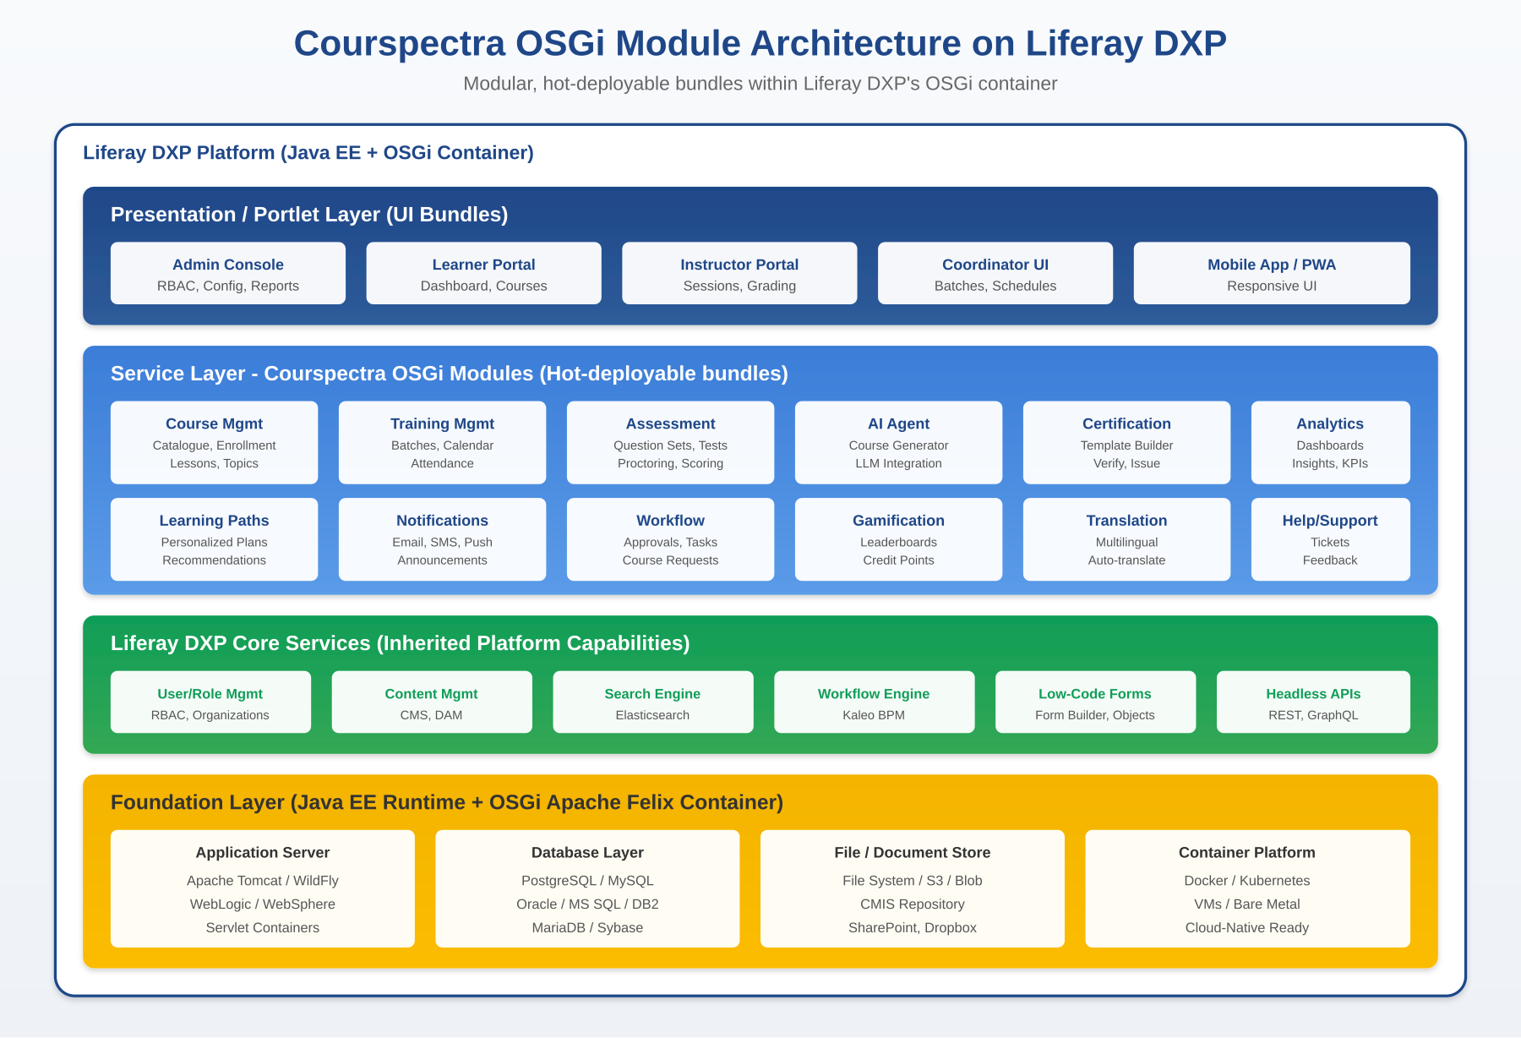
Figure 1: Courspectra OSGi Module Architecture on Liferay DXP

Module Categories
- Presentation / Portlet Layer: Role-specific user interfaces packaged as Liferay portlets - Admin Console, Learner Portal, Instructor Portal, Coordinator UI, and responsive Mobile Web App. Each portlet can be placed on pages, themed, and personalized via Liferay's site management.
- Courspectra Service Modules: Domain-specific OSGi bundles for Course Management, Training Management, Assessment, AI Agent, Certification, Analytics, Learning Paths, Notifications, Workflow, Gamification, Translation, and Help/Support. Each bundle exposes service APIs consumed by portlets and external systems alike.
- Liferay DXP Core Services: Inherited services that Courspectra leverages rather than re-implementing - User/Role/Organization Management, CMS/DAM, Elasticsearch-based Search, Kaleo BPM Workflow Engine, Low-Code Form Builder and Objects, and Headless REST/GraphQL APIs.
- Foundation Layer: Application server (Tomcat/WildFly/WebLogic), database (PostgreSQL/Oracle/MySQL/etc.), shared file or object storage (NFS/S3/Blob), and container platform (Docker/Kubernetes) - all enterprise-standard and operationally familiar to IT teams.

3.3 SCORM & Standards Compliance
- SCORM Compliance: Fully SCORM-compliant content support enabling seamless import of existing course libraries from third-party authoring tools (Articulate, Captivate, iSpring, etc.) without re-authoring.
- Accessibility Standards: Holds compliance with WCAG 2.1 AA recommended by W3C, addressing most disabilities and satisfying AA requirements for end-user-facing UIs. Configurable to meet GIGW (Guidelines for Indian Government Websites).
- Internationalization: Unicode-compliant throughout the stack, supporting labels and content in all major languages including Indian regional languages such as Hindi, Tamil, Telugu, Bengali, Marathi, Gujarati, Kannada, Malayalam, Punjabi, and Urdu.

4. Core Capabilities

4.1 Course & Training Management
Comprehensive tools to design, organize, and deliver structured learning content - from quick microlearning topics to multi-month certification programs:
- Course Catalogue: Centralized catalogue showcasing all available courses with metadata, descriptions, course imagery, credit points, ratings, and availability status. Learners can browse, search, and self-enroll based on configured policies.
- Free-Text & Fuzzy Search: Full-text search with typo-tolerance powered by Elasticsearch. Built-in filters and sort options let learners narrow results by category, language, duration, difficulty, and rating.
- Course Hierarchy: Structure courses into Lessons and Topics with unlimited nesting depth. Each topic can carry rich content, pre/post assessments, and skill tags.
- Course Detail Page: Comprehensive course view showing objectives, lessons, topics, assessments, members, feedback, and a course summary highlighting added vs. missing elements - so content managers can spot gaps at a glance.
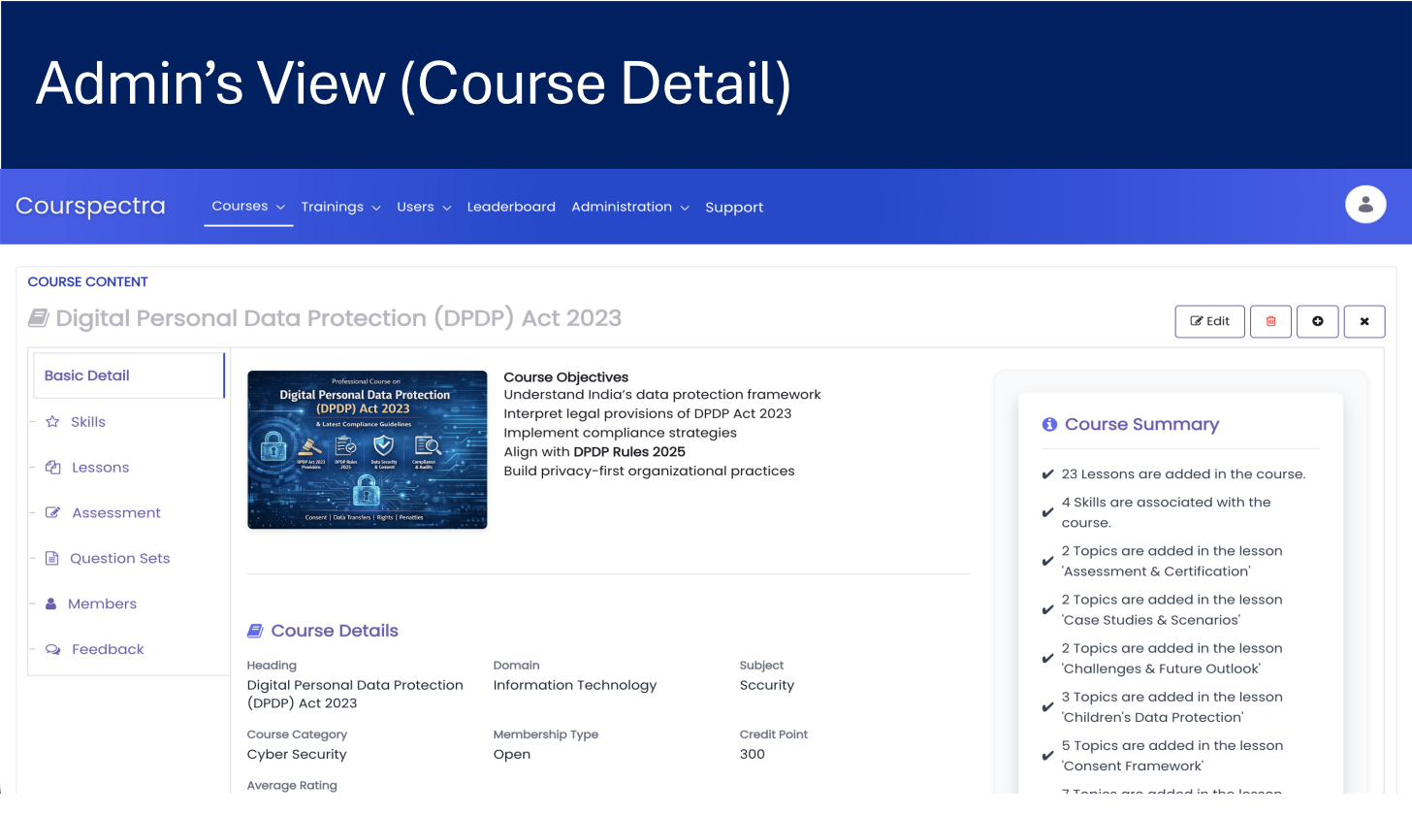
Figure 2: Admin View - Course Detail with Lessons, Skills, Assessments, Question Sets, and Course Summary
- Enrollment Workflows: Self-enrollment with optional approval workflow, admin bulk enrollment via CSV, mandatory course auto-assignment by role/department, and time-bound enrollment windows.
- Training Group & Batch Management: Create training groups and batches with configurable batch sizes (default 50). When courses attach to a training group, all members auto-enroll. Bulk trainee upload auto-distributes learners into batches dated by upload day.
- Training Schedule & Calendar: Calendar-based scheduling with trainer assignment, venue/training-center mapping, attendance capture, and integration with organizational email/calendar systems.
- Course Request Workflow: Learners can request new courses; requests route through configurable approval chains - reviewer accepts or rejects, then submits to next authority. Built on Liferay's Kaleo workflow engine.
- Multilingual Content: Author content in English and auto-translate to any supported language via the built-in Google Translator integration. Upload translated media (videos, images) separately per language. Learner sees content in their selected language.

4.2 AI-Native Learning Intelligence
Courspectra's AI capabilities are deeply embedded - not bolted on. An AI agent operates as a first-class collaborator within the platform, dramatically reducing course creation time from weeks to hours.
- AI Course Creation Form: Generate a complete course skeleton (basic info, category, domain, designation mapping, credit score, settings) from a natural language brief. The AI fills the form intelligently and creates the course in one click.
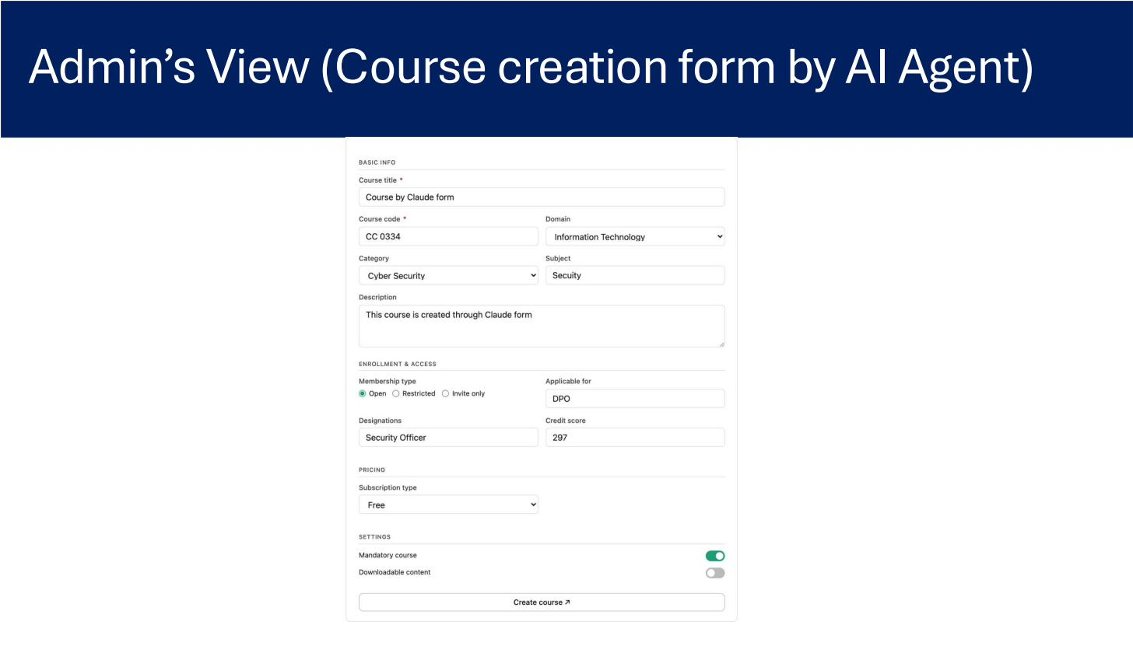
Figure 3: AI Agent Creating Course - Admin's view of the course creation form populated by the AI Agent
- AI Lesson & Topic Generation: Once a course is created, the AI generates lesson outlines and topic content automatically, working through lessons in parallel and reporting progress in a conversational interface.
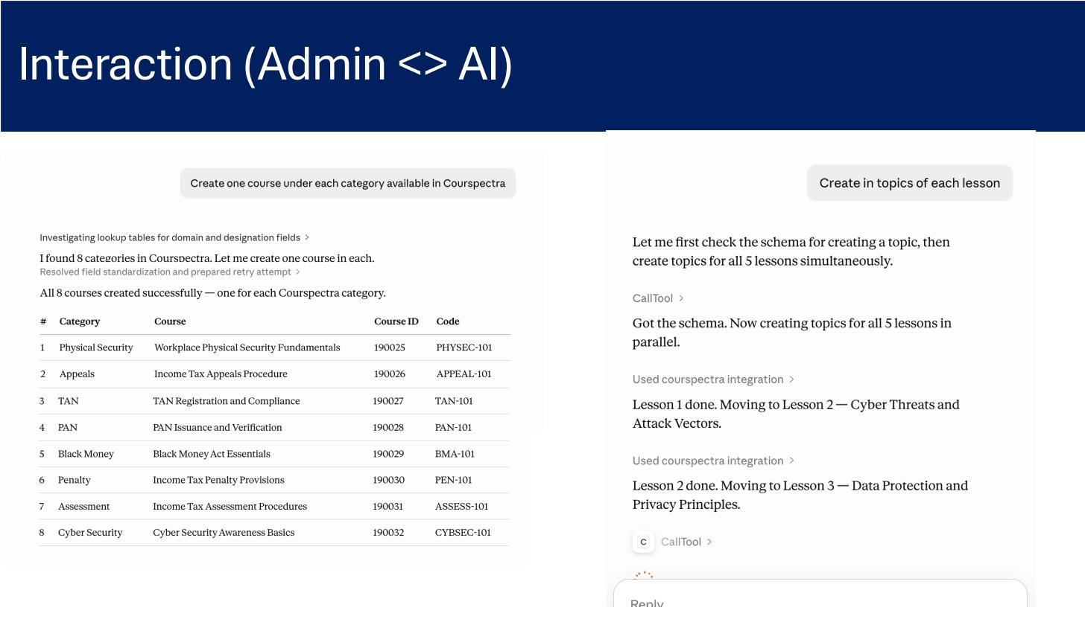
Figure 4: Admin interacting with the AI Agent to create courses across categories and generate topics for all lessons in parallel
- AI Question Set Generation: AI generates relevant question banks aligned to lesson learning objectives, with configurable difficulty mix (easy, moderate, complex) - eliminating weeks of manual question authoring.
- AI Admin Desktop: Natural-language operational dashboard where administrators can query the platform conversationally. The AI desktop surfaces platform overviews, student performance, course health, content depth, infrastructure utilization, and proactive alerts and recommendations.
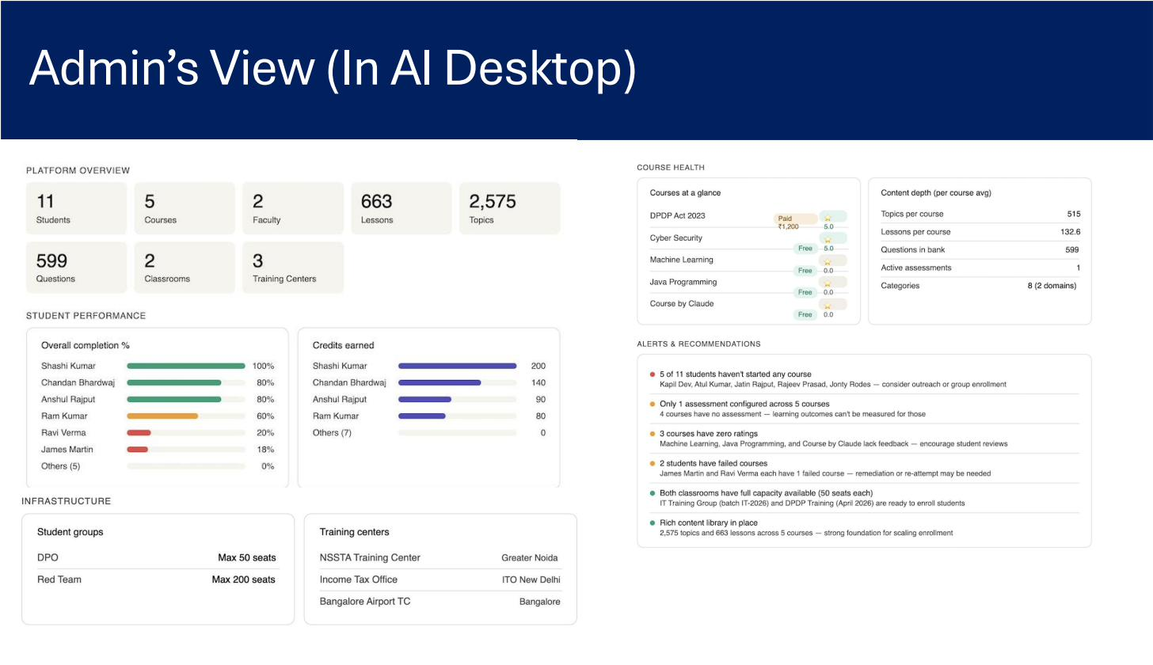
Figure 5: Admin's view of the AI Desktop - platform overview, student performance, course health, infrastructure, and alerts/recommendations
- Personalized Learning Paths: AI analyzes learner profile, performance history, and role to recommend personalized learning journeys. Learners see 'My Learning Plans' on their dashboard with target completion dates.
- Performance Prediction: AI predicts learner strength and weak areas based on assessment patterns and suggests recommended courses to address skill gaps - turning the LMS into a proactive coaching tool.
- Translation & Localization: Integrated Google Translator for automatic content localization from English to any supported language, with manual override for terminology accuracy.

4.3 Assessment & Examination
A flexible, fair, and rigorous assessment engine supporting everything from quick progress checks to high-stakes proctored certification exams:
- Multiple Assessment Types: Progress tests (per lesson, taken any time during the lesson schedule), mastery tests (course-level evaluation), pre-assessments (baseline), post-assessments (final), and ad-hoc tests - each with configurable rules.
- Question Sets & Banks: Build large question banks organized by skill, lesson, and difficulty. Attach one or multiple question sets to an assessment; the system randomly picks a set per examinee for variation.
- Mixed Difficulty Configuration: Define custom difficulty levels (e.g., Easy/Moderate/Complex with custom marks) and build mixed-level question sets - so a 100-mark test can combine 30 easy at 1 mark, 20 moderate at 2 marks, and 10 complex at 3 marks.
- Per-Lesson Question Distribution: Specify how many questions to draw from each lesson; ensures even coverage of the syllabus and prevents narrow testing.
- Randomized Selection: Random question and option shuffling per examinee prevents collusion. Each learner effectively gets a unique paper drawn from the same bank.
- Bulk Assessment Upload: Upload questions in bulk via CSV/Excel templates - allowing rapid digitization of legacy question banks.
- Online Test Experience: Modern test-taking UI with countdown timer, question palette (answered, not answered, marked for review, review-not-answered), previous/next navigation, mark-for-review, and multilingual support per question.
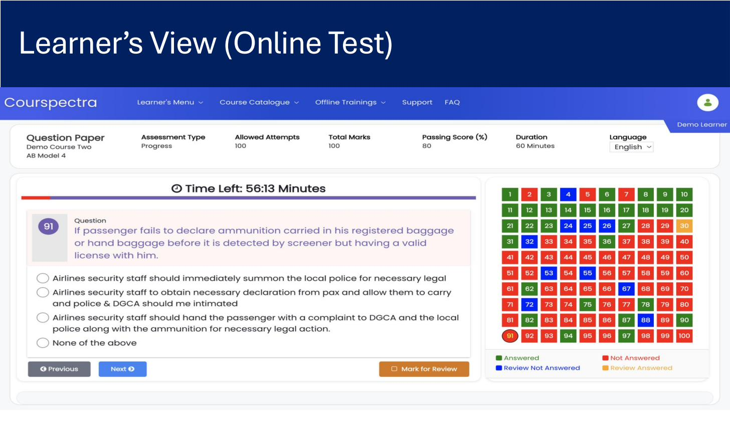
Figure 6: Learner's View - Online Test with timer, question palette, multilingual support, and mark-for-review functionality
- Proctoring: Camera-based proctoring monitors candidates during assessments - the device camera activates automatically when an assessment begins. Camera access permission is mandatory; without it, the assessment cannot start. Captures images at intervals for review.
- Configurable Scoring: Set total marks, passing percentage, negative marking, duration, allowed attempts, and re-attempt policy per assessment.
- Multiple Attempts: Allow learners configurable re-attempts with attempt history visible on dashboards. Admins see first-try pass and re-attempt counts separately.

4.4 Analytics, Compliance & Reporting
Real-time, role-specific analytics that translate learning activity into business insight:
- Admin Dashboard - Overview: Headline KPIs at a glance: Total Students, Active Courses, Training Groups, Assessments Due, Average Pass Rate - with year-over-year and period filters.
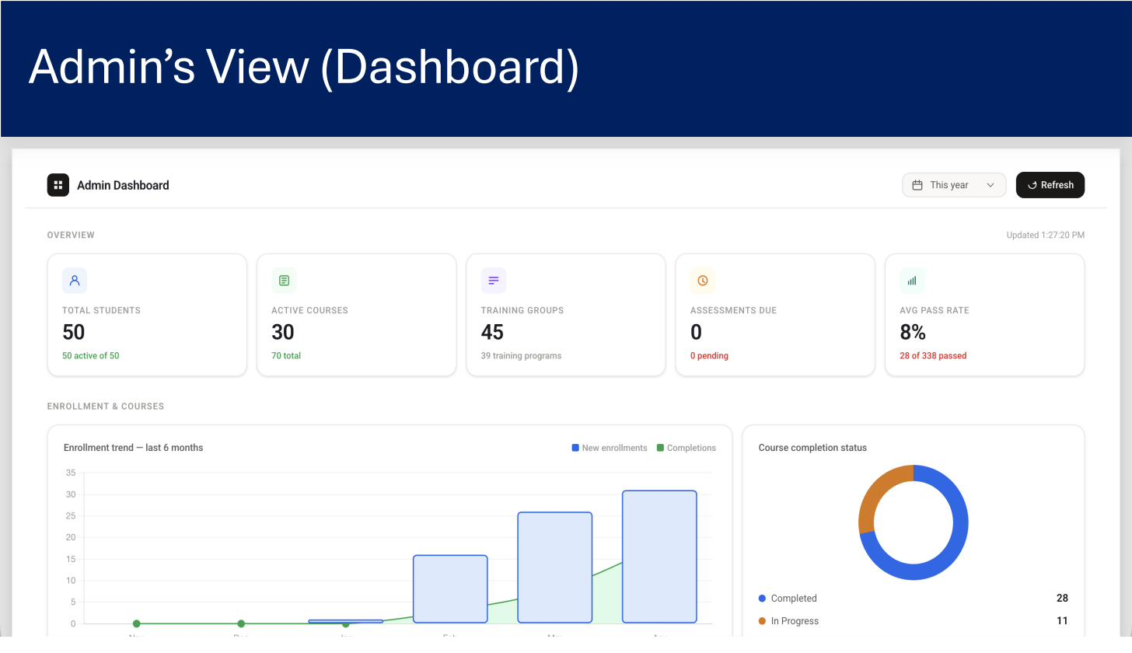
Figure 7: Admin Dashboard - Overview cards, enrollment trend, and course completion status
- Enrollment & Completion Trends: Time-series charts for new enrollments vs. completions over the past 6 months, plus a course completion status donut showing Completed and In-Progress counts.
- Assessment Performance Analytics: Score distribution histograms across all attempts, attempt summary (total, first-try pass, re-attempts), per-course pass rate, and pass-rate radar by assessment type (Progress, Mastery, Pre/Post, Ad-hoc).
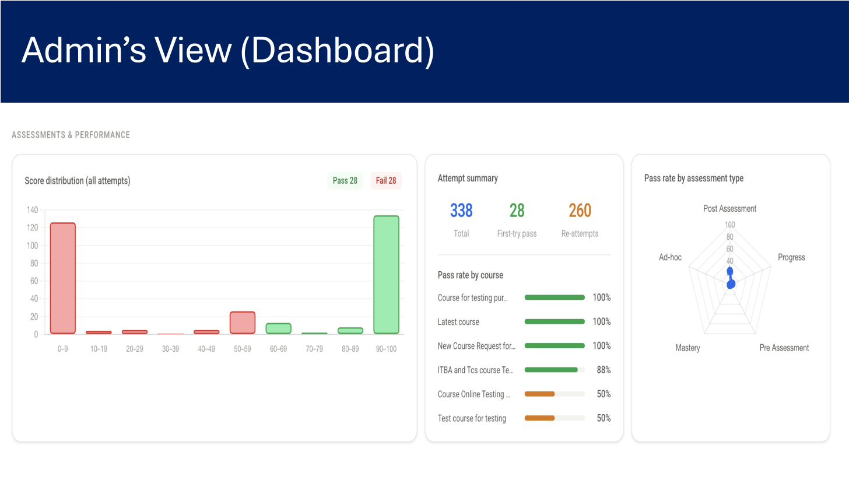
Figure 8: Admin Dashboard - Assessments & Performance with score distribution, attempt summary, and pass-rate radar
- Compliance Tracking: Monitor mandatory training completion across user populations with deadline overdue flags, auto-escalations to managers, and audit-ready reports for regulators.
- Leaderboards & Gamification: Department-filterable leaderboards rank top performers by credit points and course progress, driving engagement through healthy competition.
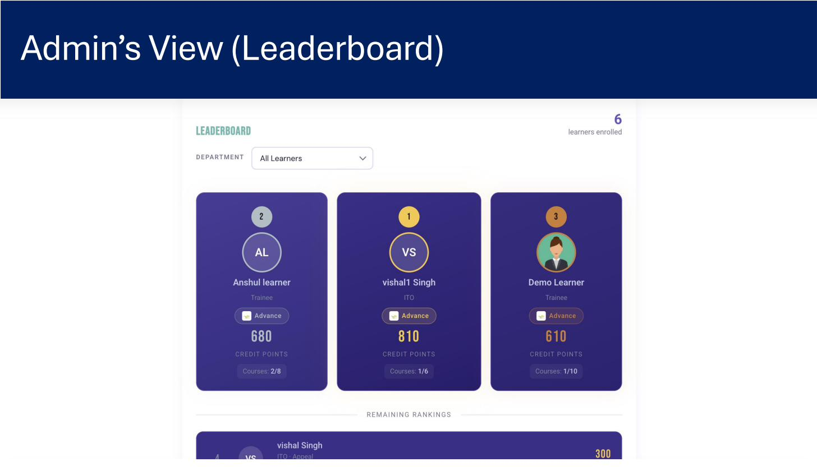
Figure 9: Admin View - Leaderboard with department filter and rankings
- Learner Insights: Per-learner analytics showing performance relative to peers, identified strengths and weaknesses, and recommended courses to address gaps - turning data into actionable development plans.
- Reports & Exports: Custom reporting with CSV/Excel export for all major datasets - enrollments, completions, scores, attendance, certificates - ready for BI tool ingestion or stakeholder distribution.
- Audit Logs: Complete activity tracking - who did what, when, from where - immutable and tamper-evident for compliance, accountability, and forensic investigation.

4.5 Certification & Credentials
- Automated Certificate Generation: Certificates auto-generate on successful course completion through final assessment and are emailed to the learner. Learners also access them anytime in 'My Certificates'.
- Certificate Template: Customizable certificate template for course completion and assessment - placeholders for learner name, course name, date, credit points, signatory, QR code, and serial number. No coding required.
- Template Version Management: Certificate templates are versioned; changes to design or wording don't break historical certificates issued under earlier versions.
- Digital & Physical Certificates: Issue digital certificates (downloadable PDF) and optionally printable physical certificates. Both carry verification IDs.
- Online Certificate Validation: Public-facing validation portal where any external party (employer, regulator) can verify a certificate by serial number or QR scan - reducing credential fraud.
- Course-Certificate Mapping: Map certificates to specific courses, assessments, and credit point thresholds; multiple certificate types per course are supported.

4.6 User, Role & Access Management
Built on Liferay DXP's mature User, Role & Organization Management, extended for LMS-specific needs:
- Bulk User Registration: Upload trainees via CSV with downloadable template. Accounts auto-create with credentials emailed to learners. Force passwords change at first login is configurable.
- Role-Based Access Control (RBAC): Granular permissions for every screen, action, and resource. Built-in roles (Administrator, Training Coordinator, Instructor, Content Manager, Learner) can be customized; new roles can be created with specific permissions.
- Organizations & Sites: Group users into organizational hierarchies (e.g., Company > Region > Department > Team) and sites (e.g., DPDP Training Site, Cyber Security Site) with site-level permissions and theming.
- Auto-Batch Assignment: Bulk upload automatically creates training groups by upload date and distributes learners into batches with admin-configurable batch size (default 50).
- Identity Federation: Built-in encrypted database authentication plus seamless integration with LDAP, Active Directory, Azure AD, Okta, and any SAML 2.0 / OAuth 2.0 / OpenID Connect identity provider.
- Trainee Registration & Approval: Configurable trainee onboarding workflows with auto-approval or multi-level review for sensitive courses.
- No Hard User Limits: The system applies no hard cap on user counts; scaling is bounded only by infrastructure. Clustered, horizontally-scalable architecture supports millions of users.

4.7 Communication, Engagement & Collaboration
- Announcements: Admins publish announcements that appear on landing pages of all users when they sign in. Optionally pushed via system notifications and email; SMTP modules can be integrated for SMS notifications.
- Student Groups & Forums: Create open or closed student groups for learner collaboration. Leverage Liferay DXP's Discussion Forums and Q&A for asynchronous conversations around lessons.
- Group Messaging: Trainers and coordinators broadcast messages to batches; learners receive in-system notifications and optional email.
- Webinar Integration: Schedule and manage live training sessions with integration hooks for Zoom, Microsoft Teams, and other webinar platforms.
- My Notes: Learners capture notes while working through courses; all notes consolidate in 'My Notes' with back-links to the source lesson - turning the LMS into a study companion.
- Help & Support: Built-in Help & Support module (built on Liferay's low-code framework) for category-based ticket submission - learners raise queries; coordinators triage; configurable categories and fields.
- Feedback Collection: Session feedback forms from learners to instructors, course-level ratings, and free-text comments - feeding into the leaderboard quality scoring.

5. User Roles & Role-Specific Features
Courspectra provides purpose-built experiences for each stakeholder in the learning ecosystem, with role-based dashboards, navigation, and permissions:

5.1 Administrator
Configures and manages the LMS while overseeing system performance and governance:
- User & Role Management: Configure organizations, roles, permissions, and user provisioning with RBAC granularity.
- Mass Registration: Bulk-onboard learners via CSV with auto-batch distribution and email credential delivery.
- Content & Training Management: Approve, publish, and manage courses, lessons, and training schedules across the platform.
- Workflow Management: Define approval workflows for course requests, enrollments, and certifications via Liferay Kaleo.
- Announcements & Webinars: Publish system-wide announcements and schedule live webinars.
- Full Analytics Visibility: Access platform-wide dashboards, compliance reports, and learner insights.
- Certificate & Template Management: Design, version, and assign certificate templates.
- Resource Activation: Activate or deactivate users, courses, and resources as organizational needs evolve.

5.2 Training Coordinator
Orchestrates training programs, schedules, and operations:
- Training Group & Batch Management: Create and manage training groups, configure batch sizes, and assign trainers.
- Schedule Management: Maintain training calendar with venue, trainer, and learner assignments.
- Attendance Tracking: Record trainer and trainee attendance for both online and offline sessions.
- Group Messaging: Send batch-level announcements and reminders.
- Trainee Registration & Approval: Manage learner registrations with approval workflows.
- Course Assignment: Assign courses to training batches; all members of the batch auto-enroll.
- Support & Feedback: Manage support tickets, collect session feedback, and act on insights.

5.3 Instructor / Trainer
Designs courses, delivers training, and tracks learner outcomes:
- Training Calendar: View assigned sessions, prepare materials, and access learner rosters.
- Attendance & Performance: Capture attendance and view real-time learner progress in their assigned batches.
- Assignment & Scoring: Create assignments, evaluate submissions, and score learners on rubrics.
- Session Feedback: Collect feedback from learners after each session for continuous improvement.
- Content Approval: Review and approve course content submitted by content managers.
- Pre/Post Assessment Design: Design lesson-level pre- and post-assessments to measure knowledge transfer.

5.4 Content Manager
Creates and curates the learning content that powers the platform:
- Course Content Management: Develop and maintain course materials - videos, documents, SCORM packages, interactive content.
- Content Structuring: Organize content into courses, lessons, and topics with clear pedagogical flow.
- Content Publishing: Publish and version content with workflow-driven approvals.
- Question Bank Management: Build and curate question banks across difficulty levels and skill domains.
- Multilingual Translation: Translate course and assessment content into supported languages, leveraging AI-assisted translation.

5.5 Learner
The core user engaging with educational content:
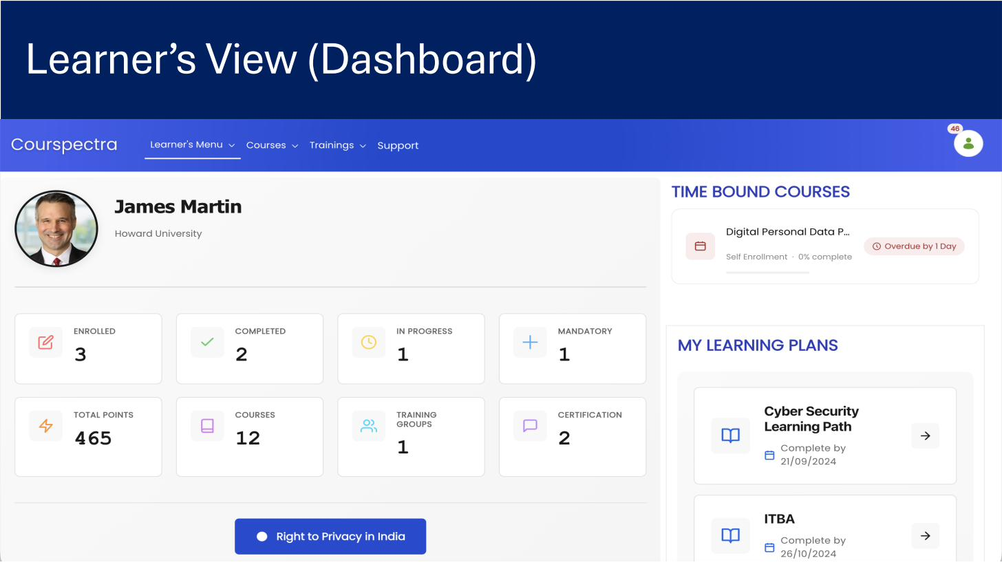
Figure 10: Learner's Dashboard - Personalized view with stats, time-bound courses, and learning plans
- Personalized Dashboard: Single-pane view of enrolled, completed, in-progress, and mandatory courses; total credit points earned; certifications achieved; learning plans; and time-bound courses.
- Online Learning Content: Access self-paced online courses with lesson-by-lesson progress tracking, in-lesson notes, and seamless resume.
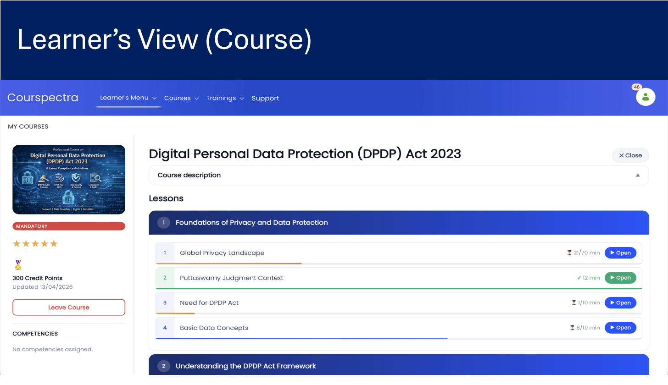
Figure 11: Learner's View - Course detail with lessons, progress bars, credit points, and competencies
- Training Schedule: View upcoming instructor-led sessions, classrooms, and webinars in a calendar view.
- Online Assessments: Take progress, mastery, and ad-hoc assessments with real-time scoring and feedback.
- Recommended Learning Plans: AI-suggested learning paths personalized to role, department, and skill goals.
- Mobile Learning: Access learning content on mobile through a responsive PWA - learn during commutes or in low-connectivity environments.
- Certificates: Download digital certificates and validate physical certificates online.
- New Course Requests: Submit requests for new courses that route through configurable approval workflows.

6. Security Architecture
Security at Courspectra is engineered as defense-in-depth - multiple overlapping controls so that no single failure compromises the system. The platform inherits Liferay DXP's enterprise security posture and adds LMS-specific controls (proctoring, certificate validation, immutable audit logs). The five-layer model below shows the protection that wraps every transaction and every byte of data.
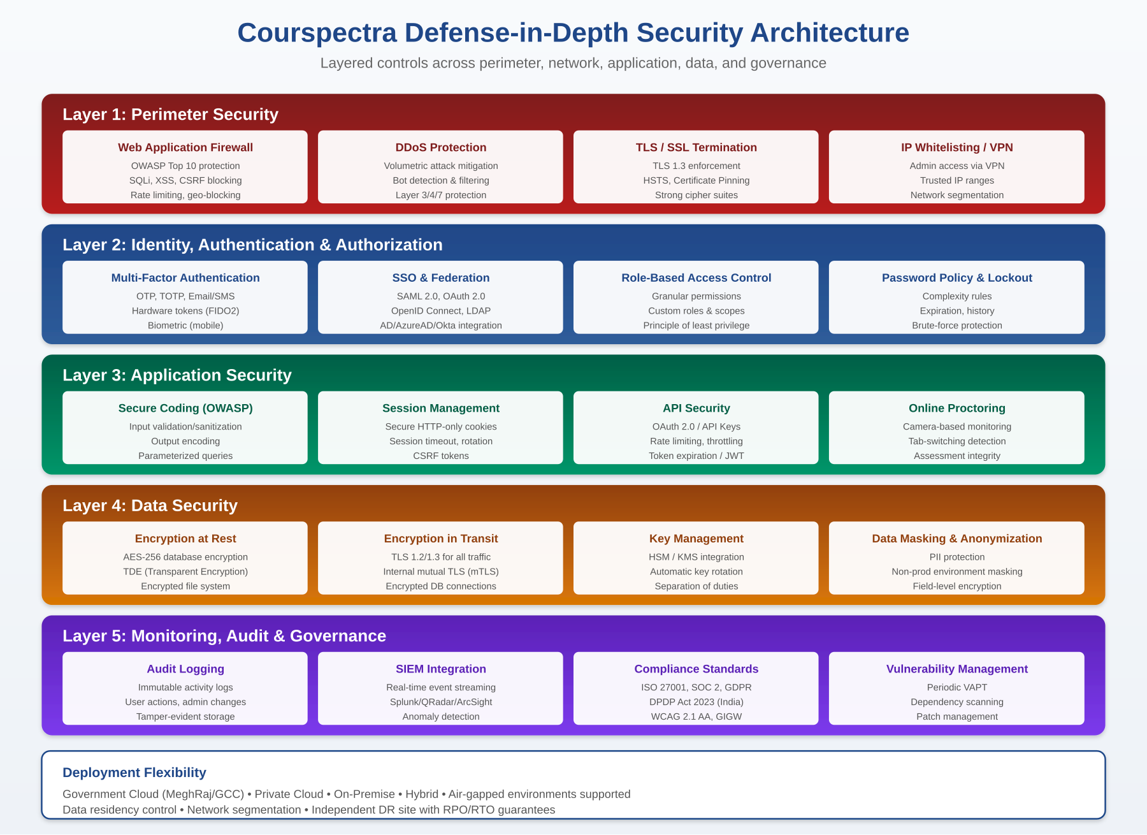
Figure 12: Courspectra Defense-in-Depth Security Architecture - Five Layers

6.1 Layer 1 - Perimeter Security
- Web Application Firewall (WAF): Filters and monitors HTTP traffic to block OWASP Top 10 attacks - SQL injection, cross-site scripting (XSS), cross-site request forgery (CSRF), command injection, path traversal, and more. Supports custom rules, virtual patching, and geo-blocking by country.
- DDoS Protection: Multi-layer DDoS mitigation absorbing volumetric (L3/L4) attacks and detecting application-layer (L7) floods. Bot detection distinguishes legitimate users from malicious automation; rate limiting throttles abusive sources.
- TLS/SSL Termination: TLS 1.3 enforced for all client-server traffic. Strong cipher suites only (forward secrecy mandatory). HSTS preload and certificate pinning protect against downgrade and MITM attacks. Automatic certificate rotation via ACME/Let's Encrypt or enterprise CAs.
- IP Whitelisting & VPN Access: Administrative interfaces can be restricted to trusted IP ranges or accessible only over corporate VPN. Network segmentation isolates admin, application, and data tiers via distinct security zones.

6.2 Layer 2 - Identity, Authentication & Authorization
- Multi-Factor Authentication (MFA): Support for TOTP-based authenticator apps (Google Authenticator, Microsoft Authenticator, Authy), email/SMS one-time passwords, FIDO2 hardware tokens (YubiKey), and biometric authentication on mobile. MFA can be mandatory for admin roles or risk-triggered for unusual sign-ins.
- Single Sign-On (SSO) & Identity Federation: SAML 2.0, OAuth 2.0, and OpenID Connect support enables seamless integration with enterprise identity providers - Azure AD, Active Directory Federation Services, Okta, Ping Identity, OneLogin, Keycloak. LDAP/AD direct integration also supported.
- Role-Based Access Control (RBAC): Powered by Liferay DXP's granular permissions model. Permissions are assigned to roles; roles to users or groups; the principle of least privilege is enforced at the screen, action, and resource level. Custom roles can be created with surgical permissions.
- Password Policy & Account Lockout: Configurable password complexity (length, character mix, dictionary checks), password history (prevent reuse), expiration intervals, and brute-force protection via progressive lockout after failed attempts.
- Session Security: Secure session cookies (HTTPOnly, Secure, SameSite=Strict), idle and absolute timeouts, automatic session invalidation on password change, and single-session enforcement options.

6.3 Layer 3 - Application Security
- Secure Coding Practices (OWASP): Development follows OWASP secure coding guidelines: input validation and sanitization, output encoding, parameterized queries to prevent SQL injection, output escaping to prevent XSS, anti-CSRF tokens, and secure deserialization.
- Session Management: Cryptographically random session IDs, session rotation on privilege change, automatic timeout after inactivity, and CSRF tokens on state-changing requests.
- API Security: REST and GraphQL APIs protected by OAuth 2.0 with JWT tokens; rate limiting and throttling per consumer; API keys for service-to-service calls; token expiration and refresh-token rotation; scope-based authorization.
- Online Proctoring: Camera-based proctoring monitors candidates during high-stakes assessments. The device camera activates automatically when the assessment begins; assessment cannot start without camera permission. Tab-switching detection and full-screen enforcement prevent navigation away from the test. Images captured at intervals for human review.
- File Upload Security: Uploaded files (videos, documents, SCORM packages) are virus-scanned, content-type-validated, and quarantined to prevent malicious uploads from being served back to users.
- Security Headers: All HTTP responses carry security headers: Content-Security-Policy, X-Frame-Options, X-Content-Type-Options, Referrer-Policy, Permissions-Policy - mitigating XSS, clickjacking, MIME sniffing, and information leakage.

6.4 Layer 4 - Data Security
- Encryption at Rest: AES-256 encryption for database storage via Transparent Data Encryption (TDE) - supported on PostgreSQL, Oracle, SQL Server, MySQL. File system encryption via LUKS (Linux) or BitLocker (Windows). Encrypted volume mounts for cloud deployments.
- Encryption in Transit: TLS 1.2/1.3 for all external traffic. Mutual TLS (mTLS) optional for internal service-to-service communication. Encrypted database connections (SSL-enabled JDBC). Encrypted backups in transit and at rest.
- Key Management: Integration with Hardware Security Modules (HSM) and cloud Key Management Services (AWS KMS, Azure Key Vault, Google Cloud KMS, HashiCorp Vault). Automatic key rotation per policy. Separation of duties - DBAs cannot access key material; KMS admins cannot access data.
- Data Masking & Anonymization: PII masking in non-production environments - real learner data never leaves production. Field-level encryption for highly sensitive attributes (national IDs, payment data). Data anonymization for analytics and reporting use cases.
- Data Residency: Deploy in specific geographic regions to meet data sovereignty requirements (e.g., India for DPDP Act 2023 compliance, EU for GDPR, US for federal data). Geo-fencing prevents data from leaving designated regions.
- Backup & Recovery: Automated encrypted backups with configurable retention. Point-in-time recovery via database transaction logs. Geo-redundant backup copies. Documented RPO/RTO targets with regular DR drills.

6.5 Layer 5 - Monitoring, Audit & Governance
- Immutable Audit Logging: Every user action, admin change, and system event is logged with timestamp, actor, action, resource, IP address, and user agent. Logs are tamper-evident (cryptographic hashing) and forwarded to immutable storage. Retention configurable per regulatory requirement.
- SIEM Integration: Real-time log streaming via Syslog/CEF/JSON to enterprise SIEM platforms - Splunk, IBM QRadar, ArcSight, Microsoft Sentinel, Elastic SIEM. Anomaly detection rules flag unusual sign-in patterns, privilege escalation attempts, and data exfiltration.
- Compliance Standards: Built and operated in alignment with ISO 27001, SOC 2 Type II, GDPR (EU), DPDP Act 2023 (India), HIPAA (healthcare), FERPA (education), WCAG 2.1 AA, and GIGW. Compliance evidence is exportable for audits.
- Vulnerability Management: Periodic Vulnerability Assessment and Penetration Testing (VAPT) by independent third parties. Continuous dependency scanning (Snyk, Dependabot) for known CVEs. Coordinated patch management with security advisories. Bug bounty program for responsible disclosure.
- Incident Response: Documented incident response plan with defined severity levels, escalation paths, and notification SLAs. Forensic capability to reconstruct timelines from audit logs. Post-incident reviews and corrective action tracking.

6.6 Government-Grade Deployment
- Government Cloud Compatibility: Deployable on government-approved cloud platforms - India's MeghRaj GCC, US AWS GovCloud and Azure Government, UK G-Cloud, and similar sovereign cloud platforms.
- Air-Gapped Deployment: Supports fully air-gapped (no internet connectivity) installations for the most sensitive environments - defense, intelligence, critical infrastructure.
- Independent DR Site: Active or warm standby disaster recovery site with replicated data, documented failover procedures, and tested RPO/RTO guarantees.

7. Deployment Architecture
Courspectra follows an n-tier deployment architecture with clear separation between web, application, search, database, and file-system layers. Each tier can be independently scaled and secured. The platform supports flexible deployment topologies - from a single-node trial to a globally-distributed multi-region production cluster.

7.1 Cluster-Based Deployment Architecture
For enterprise and government workloads, Courspectra is deployed in a clustered active-active configuration behind load balancers, with each tier horizontally scalable. The diagram below illustrates the full deployment topology:
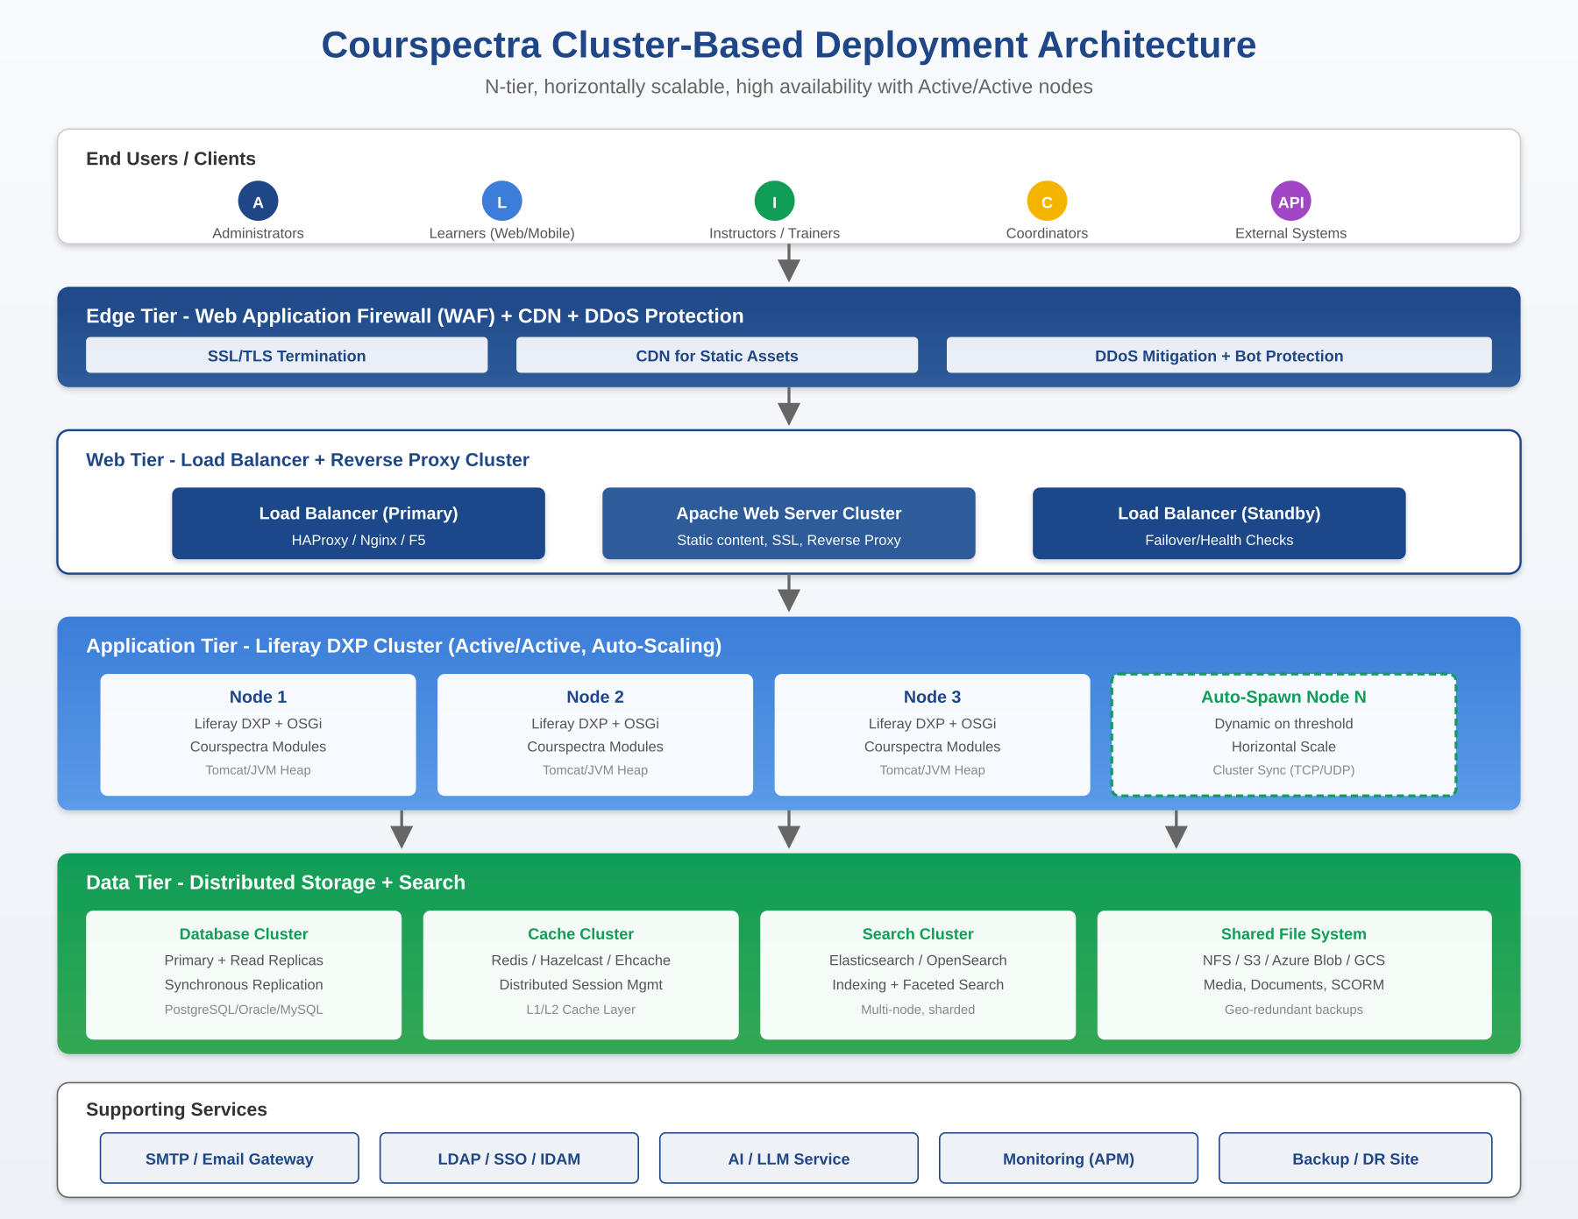
Figure 13: Courspectra Cluster-Based Deployment Architecture - N-tier, horizontally scalable, high availability

7.2 Tier Descriptions

Edge Tier
- Web Application Firewall (WAF): First line of defense filtering malicious traffic at the application layer.
- Content Delivery Network (CDN): Caches static assets (CSS, JS, images, video chunks) at edge locations close to learners, reducing latency and offloading origin servers.
- DDoS Protection: Absorbs volumetric attacks before they reach the origin infrastructure.

Web Tier
- Load Balancers: Primary and standby load balancers (HAProxy, Nginx, F5, AWS ELB) distribute requests across application nodes. Health checks remove unhealthy nodes automatically; sticky sessions optional for stateful flows.
- Reverse Proxy / Web Server Cluster: Apache HTTPD or Nginx fronts the application tier, terminating SSL, serving static content, and proxying dynamic requests.

Application Tier
- Liferay DXP Cluster: Active-active cluster of Liferay DXP nodes, each running the full Courspectra OSGi module set. Nodes synchronize via Cluster Link (TCP/UDP) for cache invalidation and event broadcast.
- Auto-Scaling: When load exceeds defined CPU, memory, or response-time thresholds, new nodes spawn automatically (Kubernetes Horizontal Pod Autoscaler, AWS Auto Scaling Groups, etc.) and join the cluster - eliminating peak-time slowdowns.
- JVM Tuning: Each node runs on tuned JVM (G1GC or ZGC), with heap sized to workload, JMX enabled for monitoring, and APM agents (New Relic, Dynatrace, AppDynamics) collecting performance telemetry.

Data Tier
- Database Cluster: Primary database (PostgreSQL, Oracle, MySQL) with synchronous read replicas for read scaling and failover. Connection pooling at the application layer. Automated failover via Patroni, Oracle Data Guard, or equivalent.
- Cache Cluster: Distributed cache (Redis Cluster, Hazelcast, Ehcache with replication) accelerates frequent reads, holds session state, and stores transient data. L1 cache at each app node; L2 cache shared across the cluster.
- Search Cluster: Elasticsearch or OpenSearch cluster (3+ nodes, sharded indices, replicas) powers full-text search, faceted filtering, and analytics queries. Search indexes are kept in sync via Liferay DXP's indexing pipeline.
- Shared File System: All application nodes share a common file repository (NFS, GlusterFS, AWS S3, Azure Blob, Google Cloud Storage) for media, documents, SCORM packages, and uploaded content. Geo-redundant replication for DR.

Supporting Services
- SMTP / Email Gateway: For notifications, certificate delivery, announcement broadcasts, and credential emails.
- LDAP / SSO / IDAM: Enterprise identity providers integrated for authentication.
- AI / LLM Service: AI agent capabilities backed by enterprise LLM endpoints (OpenAI, Azure OpenAI, Anthropic, or self-hosted models).
- Monitoring (APM): Application performance monitoring, infrastructure metrics, log aggregation (ELK/Splunk), and alerting via PagerDuty/Opsgenie.
- Disaster Recovery Site: Active or warm standby DR site with replicated data and tested failover procedures.

7.3 Deployment Models
- Public Cloud: Deploy on AWS, Microsoft Azure, Google Cloud, or any major cloud provider. Pre-built templates for AWS CloudFormation, Azure ARM, and Terraform accelerate provisioning.
- Government Cloud: Deploy on government-approved sovereign clouds - India MeghRaj GCC, AWS GovCloud, Azure Government - meeting data residency and clearance requirements.
- Private Cloud / On-Premise: Deploy in customer-owned data centers on bare metal, VMs (VMware vSphere, KVM, Hyper-V), or private container platforms (OpenShift, Rancher, VMware Tanzu).
- Hybrid: Mix and match - e.g., user-facing portals in public cloud while sensitive data tier stays on-premise, connected via secure VPN or direct connect.
- Containerized: Docker images and Helm charts for Kubernetes-native deployment. Suitable for cloud-native operations with GitOps, blue-green deployments, and canary releases.
- Air-Gapped: Fully offline installation for classified or critical infrastructure environments - all dependencies bundled; no internet required for runtime.

8. Integration & APIs
Courspectra is designed to fit into your existing technology ecosystem - not replace it. Every module exposes well-documented APIs, and Liferay DXP's Headless framework provides REST and GraphQL endpoints out of the box.

8.1 API Capabilities
- Headless REST APIs: Every Courspectra entity (users, courses, lessons, topics, enrollments, assessments, certificates) is accessible via REST APIs. Pagination, filtering, sorting, and field selection are standard. Open API/Swagger documentation auto generated.
- GraphQL Endpoint: A unified GraphQL endpoint for clients that need to query multiple entities in a single round-trip - ideal for mobile apps and modern frontends.
- Module-Level Service APIs: Each OSGi module exposes its own service interface, allowing module-specific integration (e.g., a custom plugin that intercepts course enrollments).
- Webhooks: Event-driven integration - subscribe to events like enrollment created, assessment completed, certificate issued, course published and receive HTTP callbacks to your systems.
- Bulk Data Export: Scheduled and on-demand exports of enrollments, completions, scores, attendance, and certificates in CSV/Excel/JSON formats for BI tools (Power BI, Tableau, Qlik) and data warehouses.

8.2 Common Integrations
- HR Information Systems (HRIS): Integration with SAP SuccessFactors, Workday, Oracle HCM, Darwinbox, and Zoho People for user provisioning, organizational hierarchy, and skill profile sync.
- Identity Providers: Active Directory, Azure AD, Okta, Ping Identity, OneLogin, Keycloak via SAML/OAuth/OIDC/LDAP.
- Communication Platforms: Microsoft Teams, Slack, Zoom, Google Meet for webinar scheduling and notifications.
- Email & SMS Gateways: SMTP for transactional emails; SMS gateway integration (Twilio, MSG91, AWS SNS) for OTP and reminders.
- BI & Analytics: Native CSV/Excel export; database read replicas for direct BI ingestion; or push to Snowflake, BigQuery, Redshift via scheduled jobs.
- Payment Gateways: For paid courses or external learners - Razorpay, Stripe, PayPal, PayU integration via OSGi extension.
- Performance Management: Sync learning completion and skill achievement into talent management and performance review tools.

9. Customization & Extensibility
Courspectra recognizes that every organization is different. The platform offers customization at every layer:

9.1 UI Customization
- Theming: Apply organizational branding - logos, colors, typography - via Liferay DXP themes. Multiple themes for different sites or user groups.
- Page Layout: Drag-and-drop page builder to assemble dashboards, landing pages, and content pages from widgets and portlets.
- Custom Portlets: Develop custom portlets in Java, JavaScript (React, Vue, Angular), or any JVM language and deploy as OSGi bundles.

9.2 Functional Customization
- Workflow Customization: Define custom approval workflows via Liferay's Kaleo BPM engine - course request approvals, enrollment approvals, certificate validations, content publishing chains.
- Low-Code Forms & Objects: Use Liferay's low-code Objects framework to extend data models (e.g., add custom learner attributes) and Form Builder to create custom data capture screens without coding.
- Custom Roles & Permissions: Create custom roles with surgical permissions; combine multiple roles per user; site-scoped or platform-wide assignment.
- Scripting & Automation: Server-side scripting in Groovy or JavaScript for custom business logic, scheduled jobs, and data transformations.

9.3 Modular Architecture Benefits
- Pick-and-Choose Modules: Deploy only the modules you need. Don't need gamification? Don't deploy that bundle. Need a custom certification module? Develop and drop it in.
- Hot-Deploy Updates: OSGi enables hot deployment - bundles can be updated, restarted, or replaced without restarting the entire platform. Faster patching, zero-downtime upgrades for many changes.
- Version Isolation: Different bundles can depend on different library versions without conflict, thanks to OSGi's classloader isolation.

10. Platform Specifications
Key technical and operational specifications for Courspectra:
Specification | Details
Platform Foundation | Liferay DXP (Java EE + OSGi Apache Felix Container)
Programming Language | Java (Server), JavaScript/React (Client), supports any JVM language
Application Server | Apache Tomcat, WildFly/JBoss
Database Support | PostgreSQL, MySQL, MariaDB, Oracle, MS SQL Server, IBM DB2, Sybase
Operating Systems | Linux (RHEL, Ubuntu, SUSE), Windows Server, AIX, Solaris
Containerization | Docker, Kubernetes, OpenShift, VMware Tanzu, Rancher
Search Engine | Elasticsearch / OpenSearch (clustered, sharded)
Cache Layer | Ehcache, Redis (distributed L1/L2)
User Scalability | Unlimited - bounded only by infrastructure; clustered horizontal scale
Authentication | Database, LDAP, AD, SAML 2.0, OAuth 2.0, OpenID Connect, MFA, SSO
Authorization | Role-Based Access Control (RBAC) with granular permissions
Standards Compliance | SCORM, WCAG 2.1 AA, GIGW, ISO 27001, SOC 2, GDPR
Languages Supported | 20+ languages including Hindi, Tamil, Telugu, Bengali, Marathi and others; Unicode throughout
Learning Model | 100% Blended (Online self-paced + Instructor-led + Classroom + Offline)
Client Access | Desktop, Tablet, Mobile (responsive web), Native PWA, Mobile App
APIs | REST, GraphQL, Webhooks, OSGi service APIs
Deployment Options | Public Cloud, Government Cloud, Private Cloud, On-Premises, Hybrid, Air-Gapped
High Availability | Active-Active cluster, auto-scaling, multi-region DR
Trusted Since | 2016 - serving enterprises and government bodies globally

11. Why Organizations Choose Courspectra
- Proven Track Record Since 2016: Nearly a decade of production deployments at enterprises and government organizations - not a v1 product still finding its feet.
- AI-Native by Design: Built for the AI era from inception - AI agents, course generation, question generation, personalized paths, predictive insights, conversational admin desktop. Not retrofitted AI.
- Enterprise-Grade Foundation: Liferay DXP underneath means decades of platform engineering, security hardening, and operational maturity baked in - not a startup LMS hoping to scale.
- Government-Grade Security: Defense-in-depth security architecture with deployment options spanning public, government, and air-gapped environments. Meets the most stringent regulatory standards.
- Truly Multilingual: Native Unicode support, 20+ languages including Indian regional languages, and AI-assisted translation - serving global and multilingual workforces equally well.
- Unlimited Scalability: No hardcoded user limits. Clustered, horizontally scalable, with auto-spawn during peak load. Scales from 1,000 to 1,000,000+ users on the same architecture.
- Measurable Business Impact: Advanced analytics connecting training activity to performance results. Compliance, skill gap, and ROI insights at executive dashboards.
- Truly Blended Learning: Online, instructor-led, classroom, webinar, mobile, offline - all unified under one tracking and certification engine. Not just an online course portal.
- Flexible Deployment: Cloud, on-premise, government cloud, hybrid, air-gapped - your choice, not vendor-locked.
- Modular & Customizable: OSGi modularity means you deploy what you need, customize what you want, and upgrade without rip-and-replace.

12. Implementation & Support
Courspectra is delivered with end-to-end implementation support to ensure your deployment succeeds:
- Discovery & Solution Design: Workshops to capture your learning goals, user populations, compliance needs, integration touchpoints, and operational constraints. Output: a tailored solution design and deployment plan.
- Infrastructure Setup: Cloud provisioning, on-premises installation, or containerized deployment - executed by certified Liferay DXP and Courspectra engineers.
Configuration & Customization: Branding, role configuration, workflow setup, integration with IDPs and HR systems, custom portlet development, and certificate template design.

- Content Migration: Import existing SCORM courses, question banks, and learner records from your previous LMS. Optional content authoring services available.
- Administrator Training: Comprehensive train-the-trainer programs for your admins, training coordinators, instructors, and content managers - delivered onsite or virtually.
- User Onboarding: Phased rollout plans, communication templates, learner enablement materials, and adoption campaigns to maximize day-one engagement.
- Ongoing Technical Support: Tiered support with SLA-backed response times. 24x7 critical issue support available. Dedicated account management for enterprise customers.
- Maintenance & Updates: Quarterly feature releases, monthly security patches, and emergency hotfixes. Coordinated upgrade planning with regression testing.
- Documentation & Self-Service: Comprehensive admin and learner documentation, FAQ library, video tutorials, and an active community for peer support.
- Continuous Improvement: Quarterly business reviews to track adoption metrics, surface opportunities, and roadmap new capabilities aligned to your evolving needs.

13. Get Started
Ready to transform your organization's learning? Whether you're modernizing a legacy LMS, launching a new compliance program, or building a digital training capability from scratch, Courspectra brings together the foundation of Liferay DXP and the intelligence of an AI-native LMS to deliver measurable outcomes.

Connect with the Courspectra Team
Website: https://courspectra.com
Book a Demo: https://courspectra.com/book-a-demo
Contact Us: https://courspectra.com/contact-us

Designed & developed by – Armantec Systems Private Limited
Transform Organizational Learning with Courspectra
AI-Native • Built on Liferay DXP • Trusted Since 2016

